Service Opportunities
ASC: Area Service Conference
1st Sun, 1:30 pm (location rotates)
Discussion of area service and business.
Activities
2nd Sunday, 2:30pm, Step One
Plans and coordinates area activities and event calendar.
H&I (Hospitals and Institutions)
3rd Sunday, 1:30pm, Broadway
Carries the message into facilities where addicts cannot get out to regularly scheduled meetings. Please attend for time and locations.
Helpline
2nd Sunday, 1:30pm, Step One
Carries the message to addicts via our area help line.
Outreach
3rd Thursday, Restored to Sanity, 7pm
(check activities calendar for Posse trips)
Resource for area groups
Public Information
2nd Sunday, 3:00pm, Step One
Informs the public that NA exists and offers recovery from the disease of addiction.
Web
2nd Sunday, 3:30pm, Step One As needed only, no regularly scheduled meetings…..
Manages area website and electronic communications.

ASO-BOD (Area Service Office Board of Directors)
Last Monday@7:30 pm at the ASO
Serves Area with literature and other recovery
materials. E-mail: fwaso@yahoo.com

Narcotics Anonymous
Ft Worth Area Meeting Directory
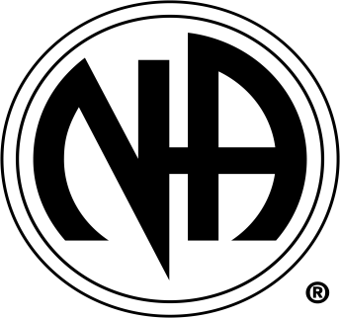

Narcoticos Anonymous
Reuniones de la Area
www.fwana.org
24 Hour Helpline
817-624-9525
For meetings outside of the
Fort Worth Area call:
888-NA WORKS
(888-629-6757)
24 horas linea de ayuda española
888-600-6229
Area Service Office (ASO)
6816 Camp Bowie Blvd. West Ste 124
Fort Worth, TX 76116
PO Box 470033
Fort Worth, TX 76147
817-335-6360
Mon 10a-2p, 7:30p-9:30p, Wed and
Thu 10-2p
Wed 10a-4p
Guide to Meeting Schedule

Closed/Open: If a meeting time is surrounded by ( ), it is a closed meeting. This just means it is for addicts only. All other meetings are open to anyone, though we ask that only addicts share.

BN= Birthday Night. This is a monthly celebration of those who have celebrated lengths of clean time during that month.

GC= Group Conscience. This is a business meeting for that group.

Bus Lines. If a group is on a bus line, it has a T: and the bus number after the group name. Refer to the-t.com for more information about the local bus system.

ask ask-it basket meeting
cl candle light meeting
bl black light meeting
lit literature study meeting
me men’s meeting
nc topics for newcomers
(newcomers are welcome at all NA meetings)
sp speaker meeting
ss step study meeting
wo women’s meeting
yp young persons’ meeting
bk book study
~ this meeting permits smoking
% this group is handicap accessible
BT Basic Text Book
LC Living Clean Book
HW It Works How and Why Book
IP Informational Pamphlet

This meeting schedule was updated:

Sept 17th, 2017

Please make sure you are using the latest schedule.
Schedules are updated monthly. Submit changes to: schedule@fwana.org

